**Color Lookup**

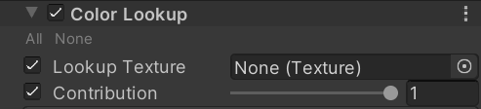

**Lookup Texture**

A custom 2D texture lookup table to apply.

**Contribution**

How much of the lookup texture will contribute to the color grading effect.

**How:**

half3 outLut = ApplyLut2D(TEXTURE2D_ARGS(userLutTex, userLutSampler), input, userLutParams);

input = lerp(input, outLut, userLutContrib);